SIMATS ENGINEERING
ASSESSMENT TOOL 1: AI Model Design Exercise
COURSE NAME: | ARTIFICIAL INTELLIGENCE AND EXPERT SYSTEMS | COURSE CODE: | MLA01

COURSE OUTCOME COVERED
CO4: Develop intelligent software agents using suitable agent architectures and learning techniques.(BTL 3)
Assessment Tool Weightage: 40 %
Total Marks: 100 Time: 90 Mins
No. of Questions: 1 Annexure A
AI Model Design Exercise

Code of Conduct:
I SAHIL.J (192525200) (Name / Reg No) certify that this submission is my original work and that I have adhered to the guidelines specified for this assessment.
I understand that any violation of academic integrity rules will result in disciplinary action.
Signature of the student: Sahil
Criterion | Weightage | Marks Obtained
1. Problem Analysis and Domain Understanding | 10%
2. Dataset Selection and Data Understanding | 10%
3. Data Preprocessing and Feature Engineering | 10%
4. AI Technique Selection and Justification | 10%
5. Model Design / Architecture | 10%
6. Algorithm / Pseudocode Development | 5%
7. Model Implementation and GitHub Repository | 15%
8. Experimental Design and Results | 10%
9. Performance Evaluation and Metrics | 10%
10. Result Analysis and Interpretation | 5%
11. Limitations and Future Enhancements | 5%
12. Documentation and Technical Presentation | 10%
Total | 100%

Signature of the Faculty Total Marks Awarded

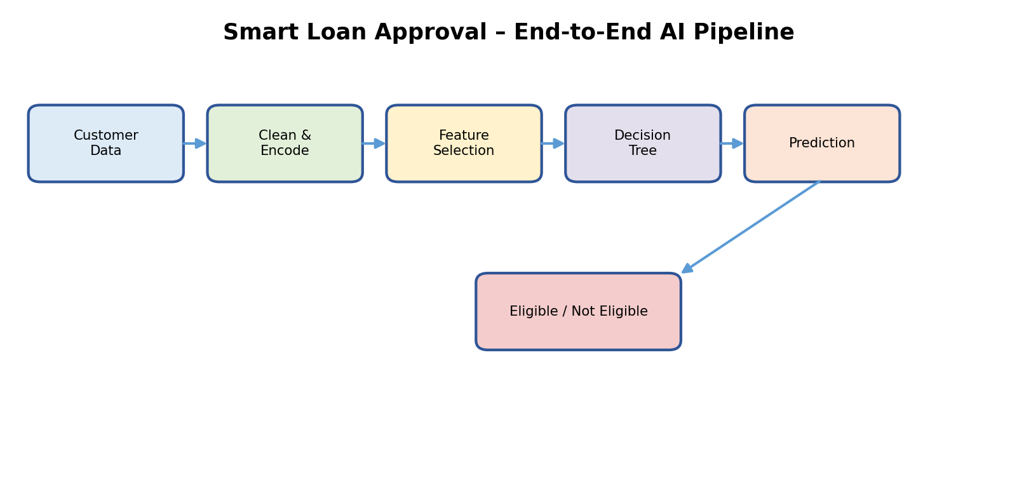1. Problem Statement & Domain Understanding
A bank needs an AI-based preliminary loan-eligibility system. The model receives customer information and produces a binary decision: Eligible or Not Eligible. The selected technique is a Decision Tree because its rule-like structure is easy to interpret and explain to banking users.
Problem Inputs
- Income – indicates repayment capacity.
- Credit Score – summarizes creditworthiness.
- Employment Status – indicates income stability.
- Loan Amount – represents requested financial exposure.
- Repayment History – indicates previous repayment behavior.
Expected Output
Customer Features → Decision Tree → Loan Eligibility
Objectives
- Build a transparent classification model for preliminary screening.
- Select a suitable attribute-splitting measure.
- Prepare data for reliable training and testing.
- Evaluate predictions with standard classification metrics.
- Provide an interpretable decision path for each customer.

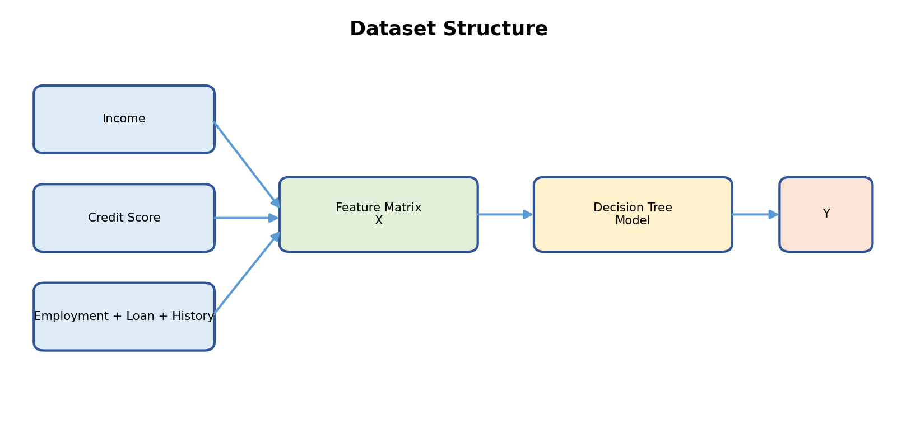
2. Dataset Selection & Data Understanding
The assessment specifies the required input attributes but does not prescribe a particular public dataset. Therefore, this report defines a suitable dataset schema for implementation; it should be populated from an approved banking dataset before reporting real performance.
Feature | Type | Example | Role
Income | Numeric | 65000 | Financial capacity
Credit Score | Numeric | 720 | Creditworthiness
Employment Status | Categorical | Stable | Income stability
Loan Amount | Numeric | 25000 | Requested amount
Repayment History | Categorical | Good | Past behavior
Loan Eligibility | Binary | Eligible | Target variable
Dataset Preparation Plan
- Remove duplicate customer records.
- Check missing values and inconsistent categories.
- Keep target label separate from input features.
- Use a reproducible train/test split.
- Document the final dataset version in the project repository.
Important
The supplied assessment does not provide a real dataset or measured sample count. Therefore, example values in this design are schema examples, not claimed experimental results.

3. Data Preprocessing & Feature Engineering
The supplied report structure asks for cleaning, missing-value handling, encoding, normalization/scaling, feature selection and train-test splitting. fileciteturn1file0L157-L160
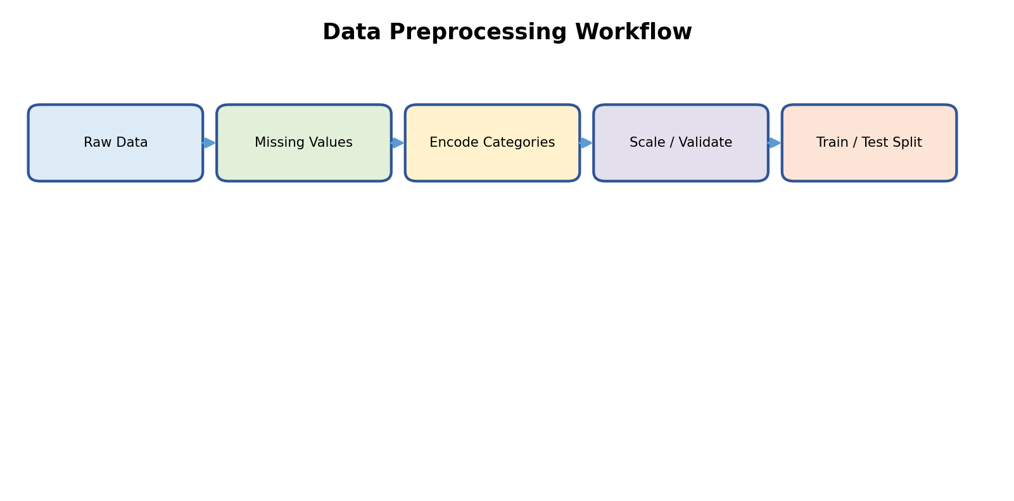
Preprocessing Steps
- Missing numeric values → impute using a documented rule such as median.
- Missing categorical values → use a documented mode or unknown-category strategy.
- Categorical encoding → convert Employment Status and Repayment History into machine-readable values.
- Outlier checks → inspect extreme income/loan values before training.
- Feature/target separation → X = customer features, y = eligibility label.
- Train/test split → keep test data unseen during model fitting.
Decision Tree note
A standard Decision Tree generally does not require feature scaling for split decisions. Scaling can still be documented if a shared preprocessing pipeline is used.

4. AI Technique Selection & Justification
Selected Technique: Decision Tree
A Decision Tree repeatedly selects an attribute and threshold/category that best separates the target classes. Each internal node represents a decision condition, each branch an outcome, and each leaf the final class.
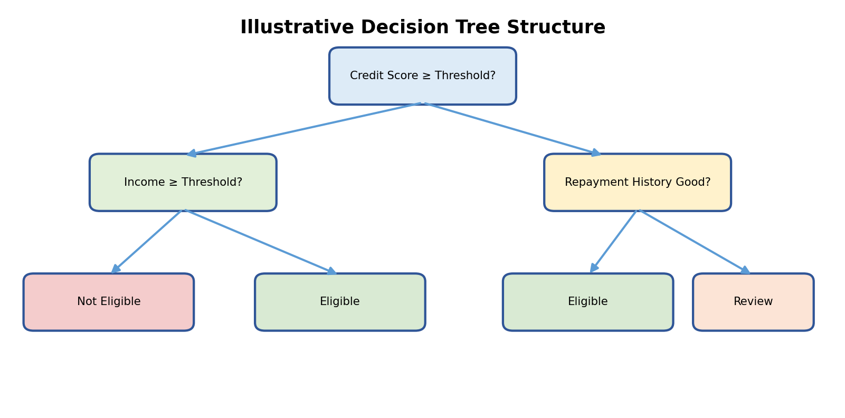
Why Decision Tree?
- Interpretability: loan officers can follow the decision path.
- Works with mixed feature types after suitable encoding.
- Represents non-linear decision boundaries through recursive splits.
- Provides a natural rule-based explanation of each prediction.
- Supports standard classification evaluation metrics.
Selection Criterion
For this design, Gini Index is selected as the primary split criterion because it measures class impurity and is straightforward for binary eligibility classification.
5. Attribute Selection – Gini Index
For a node containing K classes, Gini impurity is calculated as:
Gini(S) = 1 − Σ pᵢ²
For a candidate split, the weighted impurity of the child nodes is compared. The split with the lower weighted Gini value is preferred.
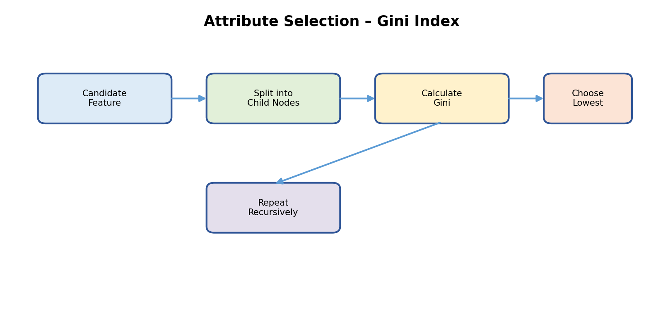

Illustrative Calculation
If p(Eligible)=0.70 and p(Not Eligible)=0.30:
Gini = 1 − (0.70² + 0.30²) = 0.42
This is a worked formula example only; it is not a reported result from a real banking dataset.
Criterion Comparison
Measure | Main idea | Use here
Information Gain | Reduction in entropy | Valid alternative
Gain Ratio | Information gain adjusted for split information | Valid alternative
Gini Index | Measures class impurity | Selected for this design

6. Model Design / Architecture
The architecture connects customer data to preprocessing, Decision Tree learning, validation and the final eligibility decision.
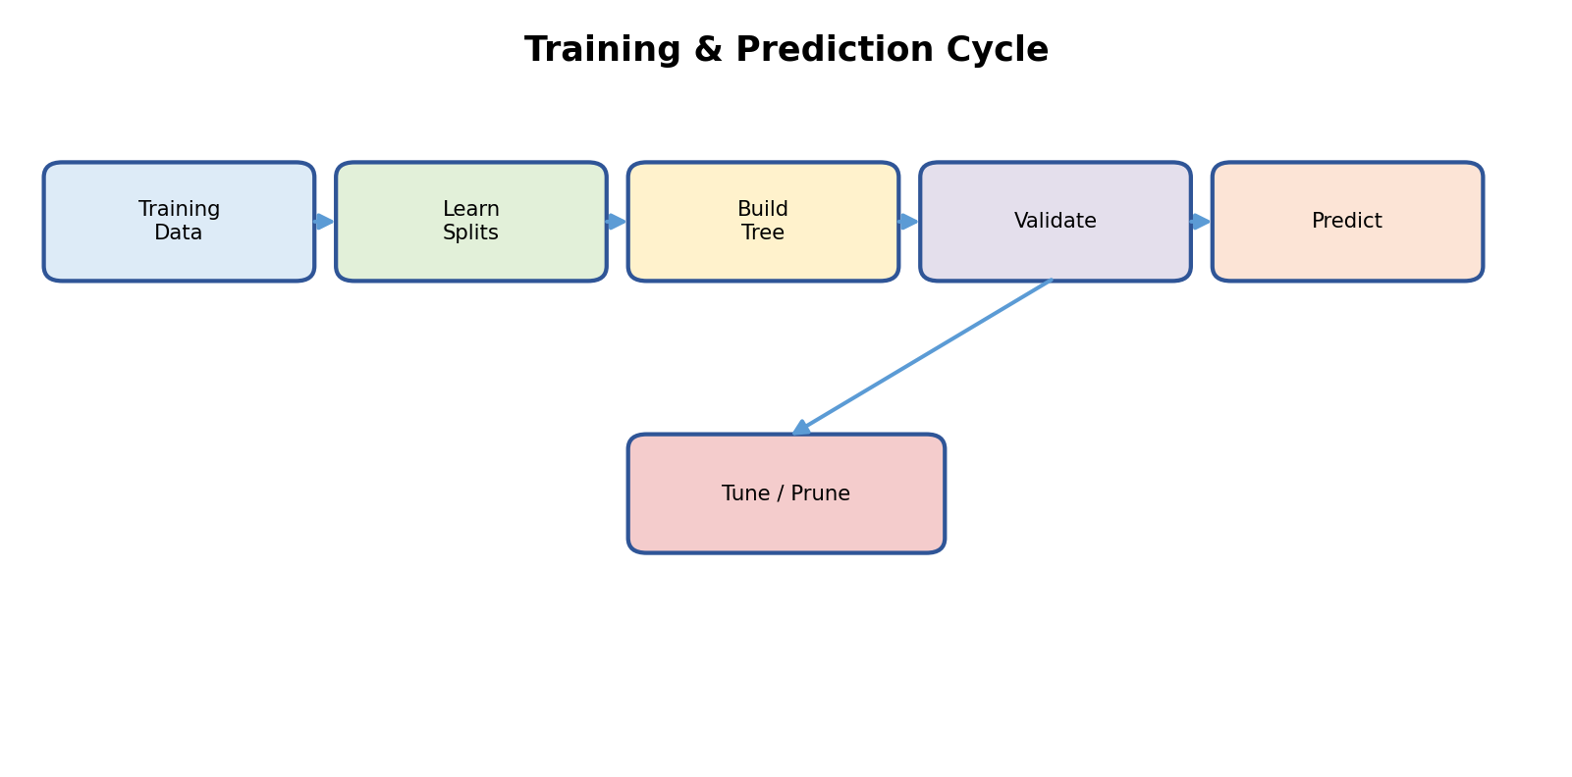
Model Components
- Input layer: five specified customer attributes.
- Preprocessing layer: validation, cleaning and categorical encoding.
- Learning layer: Decision Tree induction using Gini Index.
- Validation layer: evaluate predictions on unseen test data.
- Output layer: Eligible / Not Eligible with an interpretable path.
Key Parameters to Document
- criterion = gini
- max_depth – controls tree complexity
- min_samples_split – prevents overly small internal splits
- min_samples_leaf – stabilizes leaf decisions
- random_state – supports reproducibility

7. Algorithm / Pseudocode
The following pseudocode describes the complete model-development process.
START
1. Load approved loan dataset.
2. Separate input features X and target y.
3. Clean missing/inconsistent values.
4. Encode categorical attributes.
5. Split data into training and testing sets.
6. Initialize Decision Tree with Gini criterion.
7. Train the tree on training data.
8. Predict eligibility for test records.
9. Calculate evaluation metrics.
10. Inspect tree structure and decision paths.
11. Save the trained model and preprocessing configuration.
12. Document dataset, code, results and limitations.
END
Algorithm goal
Produce a reproducible and interpretable loan-eligibility classifier rather than an unexplained decision.

8. Implementation Plan & GitHub Repository
The supplied rubric expects a functional implementation with clean, organized, reproducible code and a complete repository with README and supporting files. fileciteturn1file0L341-L368
Recommended Project Structure
File / Folder | Purpose
data/ | Approved dataset or documented dataset source
src/preprocess.py | Cleaning and encoding pipeline
src/train.py | Decision Tree training
src/evaluate.py | Metrics and confusion matrix
models/ | Saved trained model
results/ | Tables, figures and evaluation outputs
README.md | Setup, dataset, usage and results
requirements.txt | Python dependencies
Implementation Workflow


9. Experimental Design & Results Presentation
The supplied report structure asks for results using tables, graphs, sample predictions, learning curves, confusion matrices or other relevant outputs. fileciteturn1file0L176-L179
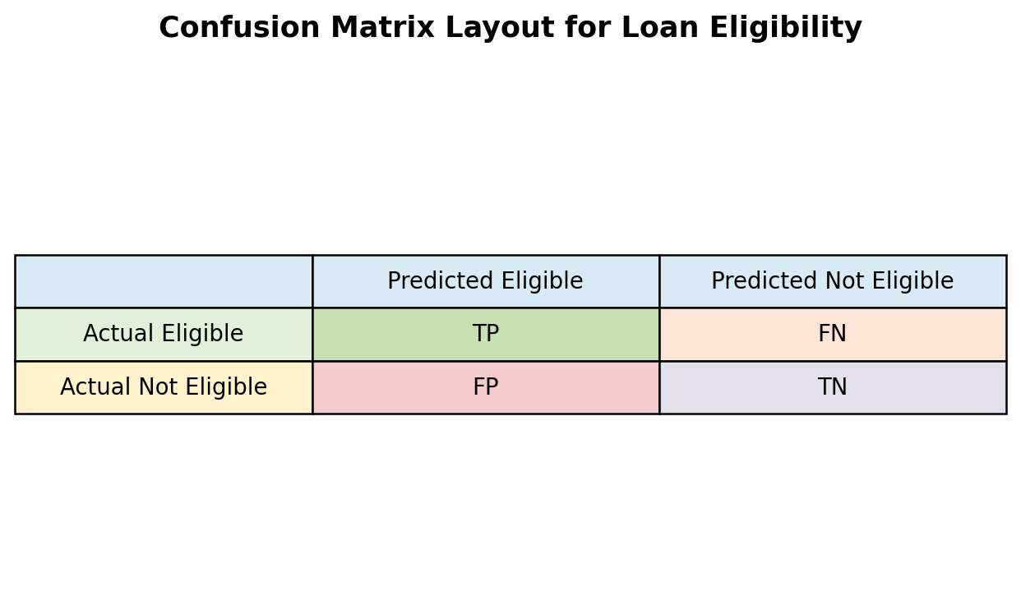
Sample Prediction Table Layout
Customer | Actual | Predicted | Correct?
C001 | Eligible | Eligible | Yes
C002 | Not Eligible | Eligible | No
C003 | Eligible | Eligible | Yes
C004 | Not Eligible | Not Eligible | Yes
Reporting rule
These rows are only a presentation template. Replace them with actual test-set predictions after implementation; do not present them as measured experimental results.

10. Performance Evaluation & Metrics
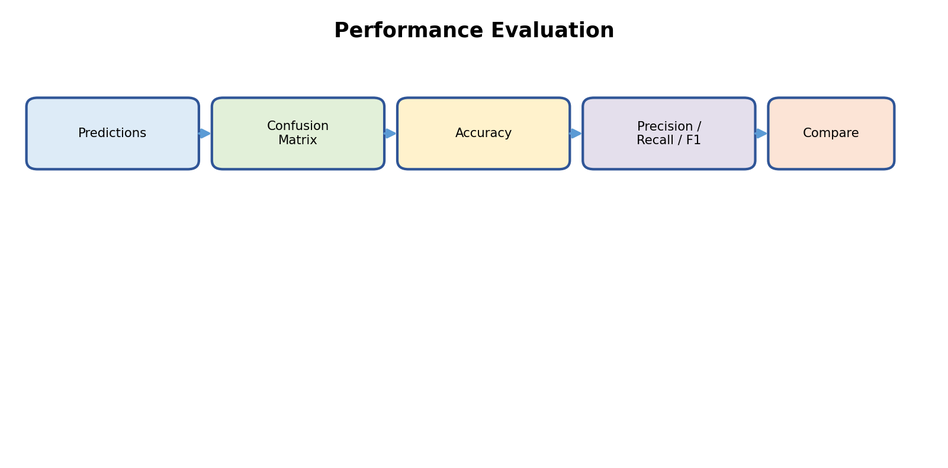
Core Metrics
Accuracy = (TP + TN) / (TP + TN + FP + FN)
Precision = TP / (TP + FP)
Recall = TP / (TP + FN)
F1 = 2 × Precision × Recall / (Precision + Recall)
Metric Interpretation
- Accuracy measures overall correctness.
- Precision measures how many predicted-eligible cases are actually eligible.
- Recall measures how many truly eligible cases are identified.
- F1 balances precision and recall when both matter.
- The final metric emphasis should reflect the bank's risk policy and the cost of different errors.

11. Result Analysis & Interpretation
The supplied rubric expects result analysis to identify patterns, errors, strengths, weaknesses and model behavior. fileciteturn1file0L415-L435
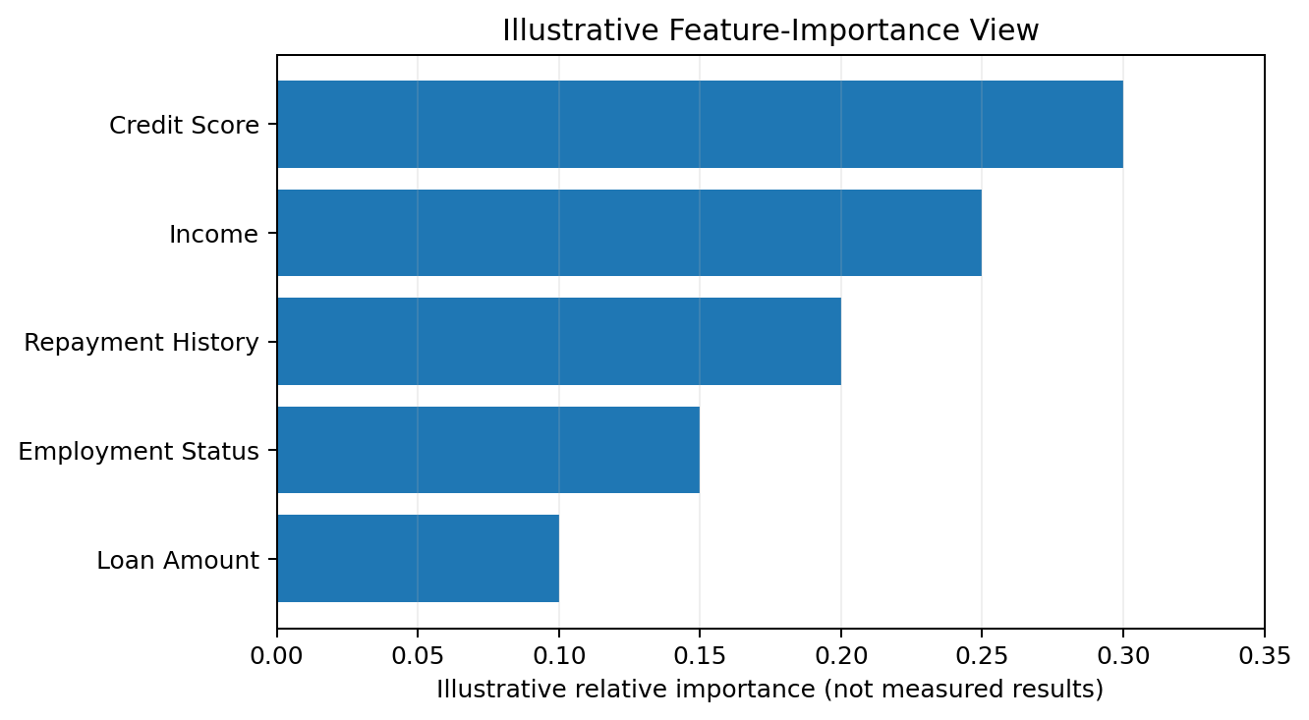
Illustrative only
The feature-importance graphic is a visual template showing how an implemented Decision Tree's feature contribution could be presented. The values are not measured results from the supplied assessment.

12. Limitations, Future Enhancements & Deployment
Limitations
- A decision tree can overfit if allowed to grow too deeply.
- Dataset bias can produce unreliable decisions.
- Loan eligibility is a high-impact decision and should not rely only on an automated model.
- Missing or outdated credit information can reduce prediction quality.
- Real deployment requires security, privacy, auditability and human oversight.
Future Enhancements
- Hyperparameter tuning and pruning.
- Compare Decision Tree with an approved baseline model.
- Add calibration and cost-sensitive evaluation.
- Use explainability reports for individual predictions.
- Monitor model/data drift after deployment.
- Validate fairness across relevant customer groups.
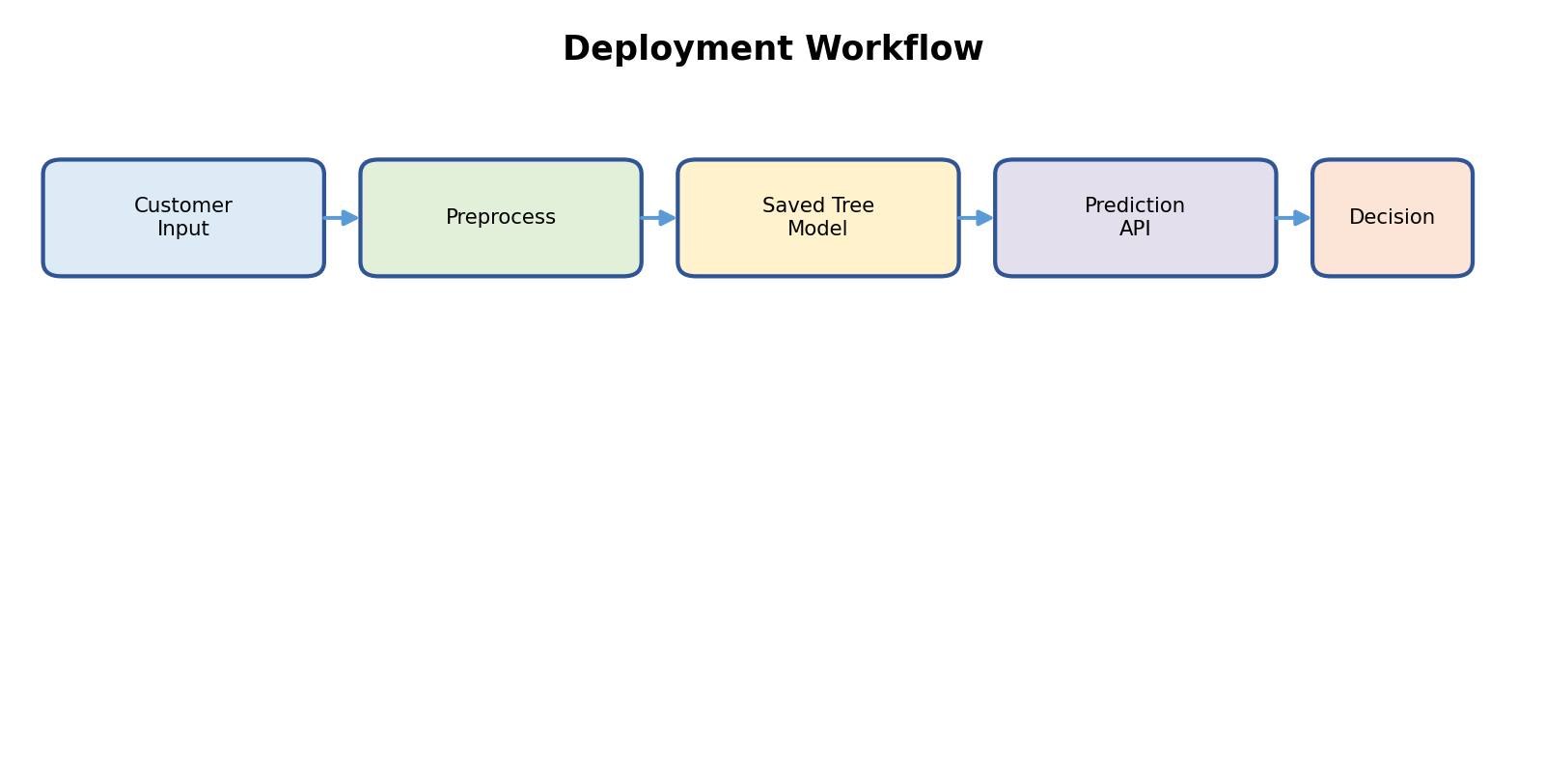
13. Conclusion, References & Rubric Checklist
The proposed Smart Loan Approval system uses a Decision Tree to map customer financial and repayment attributes to an interpretable preliminary eligibility decision. Gini Index is selected as the attribute-selection criterion, while preprocessing, reproducible training, evaluation and documentation complete the model-design workflow.
Conclusion
The design covers the core requirements of the supplied AI Model Design Exercise: problem definition, dataset schema, preprocessing pipeline, selected AI technique, model architecture, pseudocode, implementation plan, experimental presentation, evaluation metrics, interpretation, limitations, future enhancements and technical presentation.
Rubric Checklist
Rubric Area | Weight | Covered in
Problem Analysis | 10% | Page 2
Dataset Understanding | 10% | Page 3
Preprocessing | 10% | Page 4
AI Technique | 10% | Page 5
Model Architecture | 10% | Page 7
Algorithm / Pseudocode | 5% | Page 8
Implementation + GitHub | 15% | Page 9
Experimental Results | 10% | Page 10
Performance Metrics | 10% | Page 11
Result Analysis | 5% | Page 12
Limitations + Future | 5% | Page 13
Documentation / Presentation | 10% | All pages
Source Used
Primary source: uploaded SIMATS Engineering Assessment Tool 1 – AI Model Design Exercise, Course MLA01, CO4. The source defines the Smart Loan Approval scenario and the required report components and evaluation criteria. fileciteturn1file0L42-L52 fileciteturn1file0L152-L200
Final note
Replace all explicitly marked illustrative/template values with the actual dataset, training results, metrics and repository URL after implementation.

Evaluation Rubrics:

Criterion | Weightage (%) | Excellent | Good | Average | Poor
1. Problem Analysis and Understanding | 10% | 9–10% – Clearly analyzes the real-world problem, objectives, inputs, outputs, constraints, and expected AI outcome. | 7–8% – Understands the problem and objectives with minor omissions. | 5–6% – Shows partial understanding with some important elements missing. | 0–4% – Problem is poorly understood or incorrectly defined.
2. Dataset Selection and Understanding | 10% | 9–10% – Selects a highly relevant dataset and clearly explains features, target, source, size, and characteristics. | 7–8% – Appropriate dataset with adequate description and minor omissions. | 5–6% – Dataset is usable but description or relevance is limited. | 0–4% – Dataset is inappropriate, poorly described, or missing.
3. Data Preprocessing and Feature Engineering | 10% | 9–10% – Performs appropriate cleaning, transformation, encoding, scaling, feature selection, and data splitting with clear justification. | 7–8% – Performs most required preprocessing correctly with minor issues. | 5–6% – Basic preprocessing is performed but important steps are missing. | 0–4% – Preprocessing is inadequate, incorrect, or absent.
4. AI Technique Selection and Justification | 10% | 9–10% – Selects the most appropriate AI technique and provides strong technical justification based on the problem and dataset. | 7–8% – Appropriate technique selected with reasonable justification. | 5–6% – Technique is acceptable but justification is limited. | 0–4% – Inappropriate technique or no meaningful justification.
5. Model Design / Architecture | 10% | 9–10% – Develops a clear, technically sound model architecture with appropriate components, parameters, and workflow. | 7–8% – Model is well designed with minor omissions. | 5–6% – Basic model design is presented but lacks technical depth. | 0–4% – Model design is unclear, incomplete, or inappropriate.
6. Algorithm / Pseudocode | 5% | 5% – Algorithm/pseudocode is complete, logically correct, structured, and clearly represents the model development process. | 4% – Mostly correct with minor omissions. | 2–3% – Basic algorithm provided but contains gaps. | 0–1% – Algorithm is missing or substantially incorrect.
7. Implementation and GitHub Repository | 15% | 13–15% – Fully functional implementation with clean, organized, reproducible code and a complete GitHub repository with README and supporting files. | 10–12% – Functional implementation and well-organized repository with minor issues. | 7–9% – Partially functional implementation or incomplete repository documentation. | 0–6% – Implementation is incomplete/non-functional or GitHub repository is missing.
8. Experimental Design and Results | 10% | 9–10% – Conducts meaningful experiments with appropriate test cases and clearly presents results using tables, graphs, or visualizations. | 7–8% – Appropriate experiments with clearly presented results. | 5–6% – Limited experiments or basic result presentation. | 0–4% – Insufficient, incorrect, or missing experimental results.
9. Performance Evaluation | 10% | 9–10% – Uses appropriate evaluation metrics and provides comprehensive quantitative analysis of model performance. | 7–8% – Uses suitable metrics and provides adequate evaluation. | 5–6% – Basic evaluation with limited metrics or analysis. | 0–4% – Inappropriate metrics or performance evaluation is missing.
10. Result Analysis and Interpretation | 5% | 5% – Provides insightful analysis of results, identifies patterns, errors, strengths, weaknesses, and explains model behavior. | 4% – Provides good interpretation with minor gaps. | 2–3% – Basic interpretation with limited analysis. | 0–1% – Results are not meaningfully analyzed.
11. Limitations and Future Enhancements | 5% | 5% – Clearly identifies realistic limitations and proposes technically relevant and feasible improvements. | 4% – Identifies relevant limitations and reasonable improvements. | 2–3% – Provides basic limitations and future suggestions. | 0–1% – Missing, unrealistic, or poorly explained.
12. Documentation and Technical Presentation | 10% | 9–10% – Report is comprehensive, well organized, technically accurate, professionally presented, and properly referenced. | 7–8% – Well documented with minor presentation or referencing issues. | 5–6% – Adequate documentation with several gaps. | 0–4% – Poorly documented, unclear, or incomplete report.
Total | 100%

